Predicting Changes in Exchange Rates and Comparing Predictions of Different Machine Learning

Methods

Aalto University, August 2022.

1. INTRODUCTION:

Currency fluctuations are a natural outcome of floating exchange rates, which is the norm for most major economies. Various factors influence exchange rates, including a country's economic performance, the outlook for inflation, interest rate differentials, capital flows and so on.

A currency's exchange rate is typically determined by the strength or weakness of the underlying economy. As such, a currency's value can fluctuate from one moment to the next.

The main goal of this project is to help brokers and businesses make better decisions in crisis situations and to help governments to control cash flow and international transactions, and avoid crime like money laundering.

In order to forecast these critical situations, we could predict the future exchange rates of the currency based on the current and past rates, by using machine learning. We would train some models on a dataset we found on the [European Central Bank](https://sdw.ecb.europa.eu) and try to predict the future Swedish Krona rates.

From the previous dataset, we will explicitly use exchange rates from a specific day and use them as features, and the SEK-EUR exchange rate will be our main label.

Then we will apply two machine learning models on the training set and predict the results using the validation set. We will compare both models results and performances using loss functions, and determine the most efficient model.

1. PROBLEM FORMULATION

The problem consists of three important concepts i.e., data points, models and loss functions. Data points are some objects that carry relevant information[1], which are the exchange rates from a specific day in the project. The data points are collected from 4:th January 1999 to eighth August 2022, which are 6048 data points. Data points can also be presented by features and labels. Features are exchange rates from EUR to DKK, EUR to USD and EUR to NOK and our label is the exchange rate from EUR to SEK.

Models are hypothesis spaces and the loss functions are quality measures[2]. The main purpose is to fit models to data that consists of a set of data points, in order to get accurate predictions of the exchange rate in the future. Thereafter, the loss functions are used to measure errors’ sizes and qualities of the models.

Loss functions that are applied in the project are Mean Squared Error Loss(MSE) and Huber Error Loss. MSE is the sum of squared errors, which means that it is very sensitive to outliers because the penalty is squared. But the MSE has a form of quadratic equation as shown in Equation 1[3] and Figure 1, 2, which ensures that there is a gradient descent with only one global minimum value.

As seen in equation 2[4], Huber Error Loss is a combination of MSE and MAE that is the average of absolute errors. As shown in figure 3 and 4, if the prediction error is too big, the penalty becomes MAE, which decreases the sensitivity of outliers.

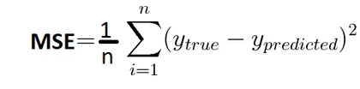

Equation 1, formula for MSE.

Figure 1, illustration of MSE.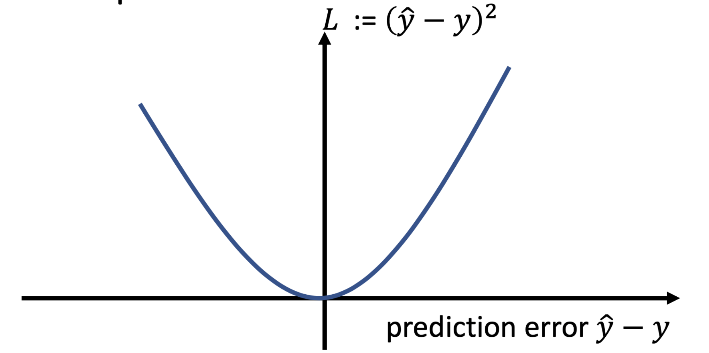

Figure 2, illustration of outliers for MSE.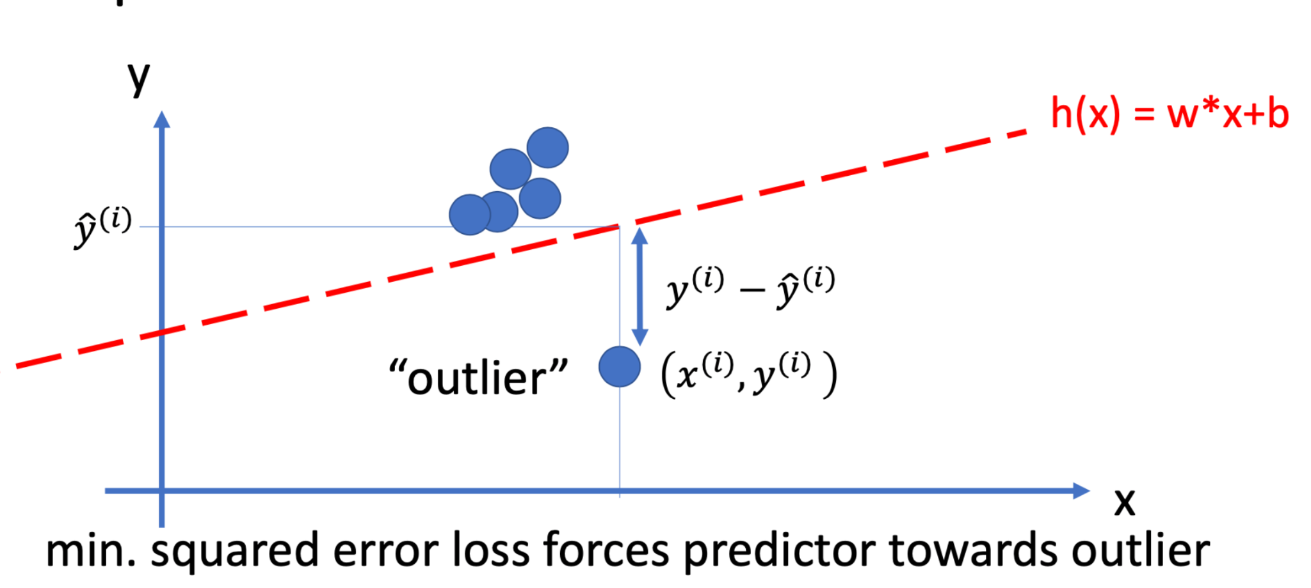

Equation 2, formula for Huber Error Loss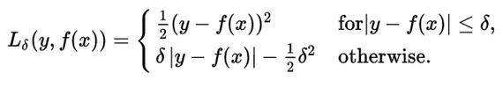

Figure 3, illustration of Huber Error Loss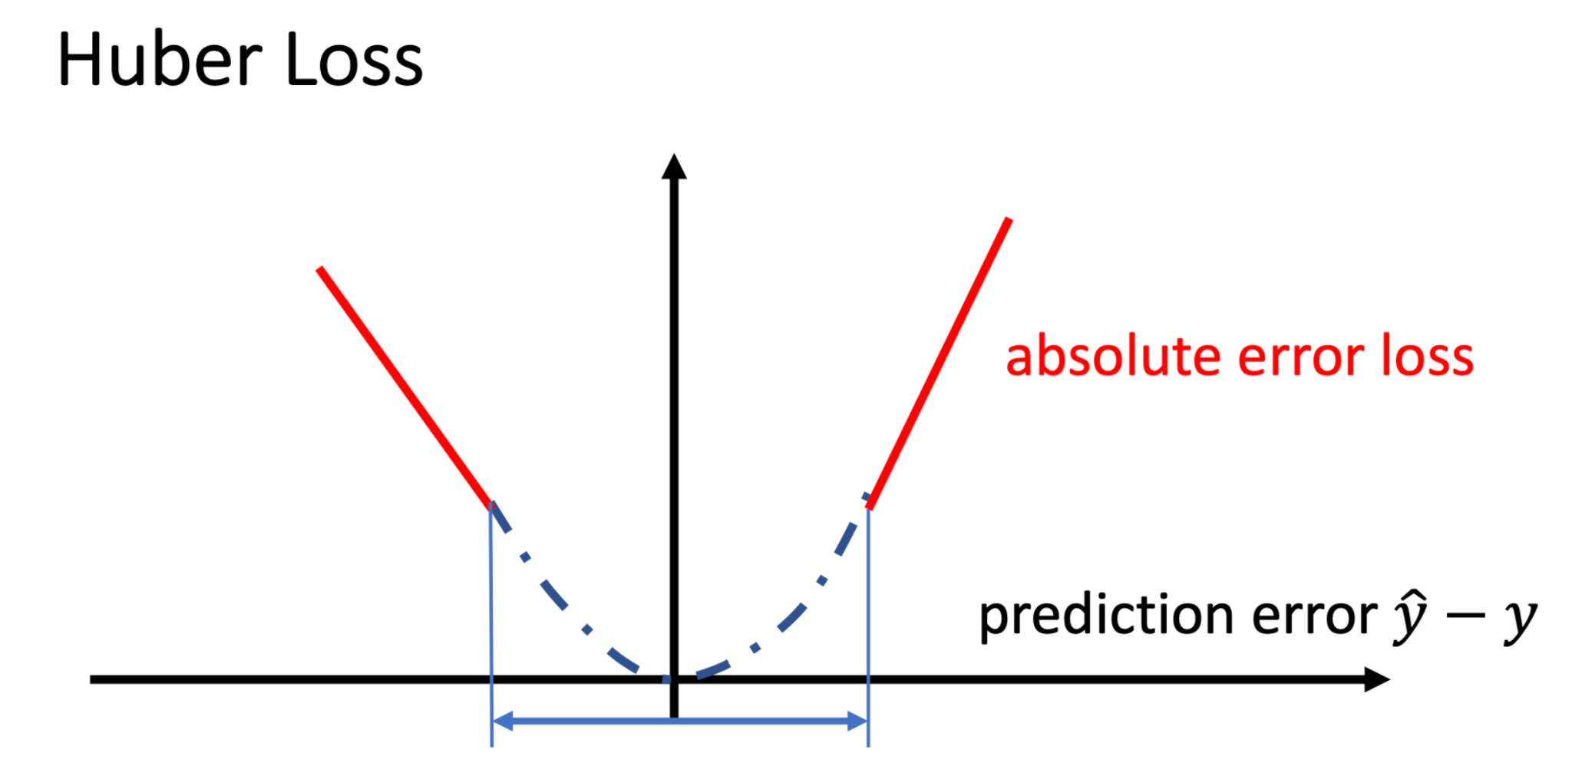

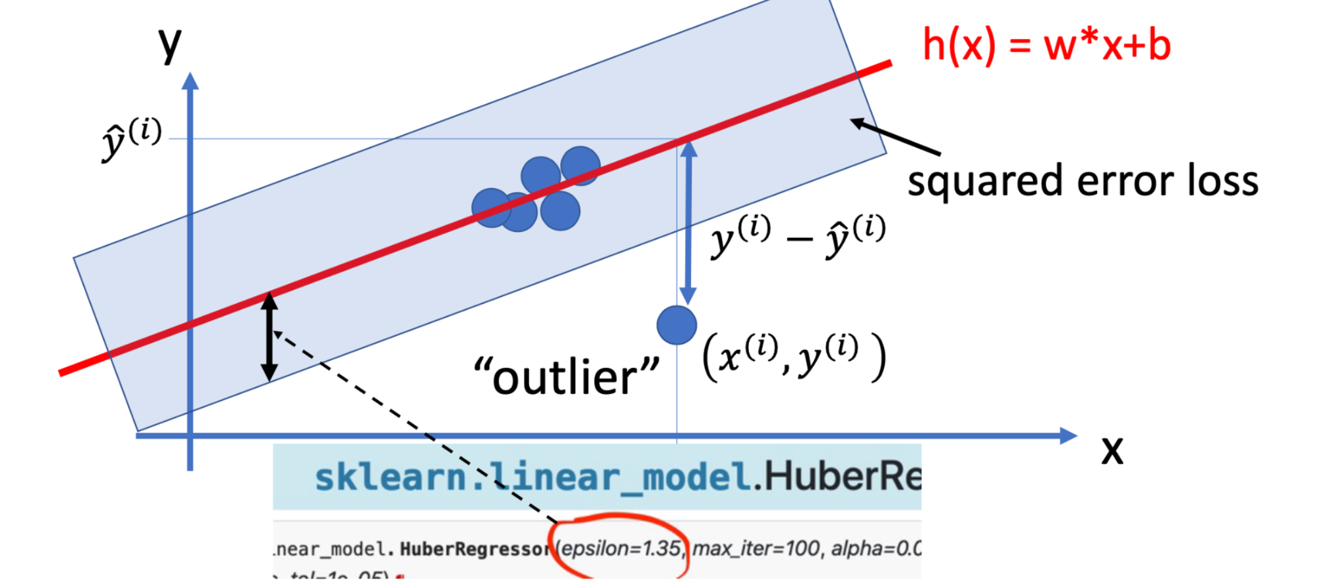

Figure 4, illustration of outliers for Huber Error Loss.

As a benchmark we use the last two years’ worth of data to validate the performance of the model in a very unpredictable economical situation.

1. METHODS

For Predicting the exchange rates from EUR to SEK we used two different kinds of models. The first one is the Multiple Linear Regression model. It uses linear maps to predict the label for a given feature vector. We chose this model, because the multiple variables that are used in this model helps us to be better armed against the fluctuations of the Exchange Rate. For the implementation of the Linear Regression we use the sklearn.linear_model.LinearRegression class.

The Linear Regression uses the Mean Squared Error (MSE) as a Loss function, which makes it prone to outliers, but because of the quadratic formula it ensures that it has only global minimum. For calculating the MSE we used the sklearn.metrics.mean_squared_error method.

Our second model is the Huber Regression. It also uses linear maps to predict labels. We chose it because it uses a different loss function than the Linear Regression, which makes it more robust to outliers. For loading and training this model we used the sklearn.linear_model.HuberRegressor class.

The Huber Regression uses the huber loss as a Loss function. In a bandwidth, which is determined by the value of epsilon, it uses the MSE and outside of this bandwidth it uses the absolute error. The combination of these methods makes the huber loss more robust against outliers. To calculate the Huber loss we used our own implementation, which can be seen in the notebook which is added at the end.

We got our data from the European Central Bank (ECB). The data is publicly available at https://sdw.ecb.europa.eu/. We splitted in a training (1999-01 to 2019-12), validation (2020-01 to 2021-12) and test set (2022-01 to 2022-08).

We didn’t use a Polynomial Model, because of the higher risk of overfitting.

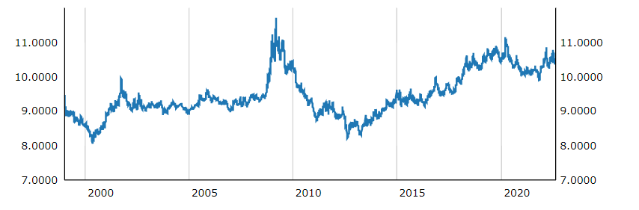

Figure 5: Development of the exchange rate from EUR to SEK in the period from 1999 to 2022[5]

1. RESULTS

The appended notebook provides the used implementation of the methods described in the previous section, and they return the following errors:

| **Method** | **Training error** | **Validation error** |
| --- | --- | --- |
| Linear | 0.1692 | 0.1473 |
| Huber | 0.0874 | 0.0228 |

Table 1: Training and Validation errors

From this table it can be seen that Huber Regression returns approximately half of the training and validation errors when compared to Linear Regression. This would imply that Huber regression is better for this data, but there might still be overfitting or a prediction that doesn’t make sense. Because of this, the results are also compared visually by plotting them both. Due to the nature of the data and prediction, it is illustrated by plotting them as time series with the predictions appended to the end, on top of the true labels.

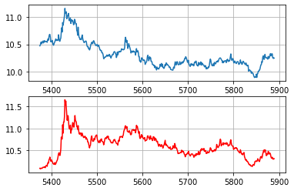

Figure 6: True labels (blue) and Linear Regression prediction (red) for the Validation set

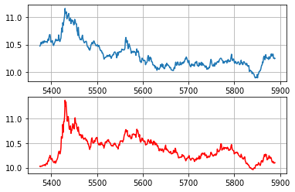

Figure 7: True labels (blue) and Huber Regression prediction (red) for the Validation set

It can be observed from Figures 6 and 7 that the predictions are very nearly equivalent. However, as can be seen in the results in Table 1, Huber Regression appears to result in more accurate predictions on average regardless.

Analyzing the residuals of a model is another method of evaluating its performance. Residuals are assumed to be i.i.d. and follow a normal distribution with a mean of 0. Thus, the residuals of a well-fitted model follow such a distribution.

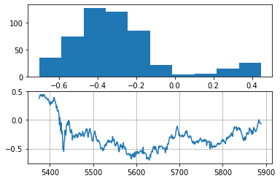

Figure 8: Linear Regression residuals as histogram and time series plots for the Validation set

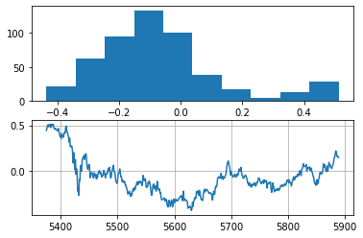

Figure 9: Huber Regression residuals as histogram and time series plots for the Validation set

A statistical test is not needed to conclude that the residuals of either model are not normally distributed, which is not ideal. Both Figures 8 and 9 show signs of being skewed to the right.

Based on the chosen error measurements, the visual evaluation of predictions and the residual analysis, Huber loss was chosen for Test evaluation. The calculated test error of the model for the test set is 0.0951.

1. CONCLUSIONS

In this report we forecast exchange rates from EUR to SEK by using Multiple Linear Regression and Huber Regression models. Table 1 shows us that both models perform better on the validation set than on the training set, which shows that there is not much overfitting. Furthermore the validation error of the Huber Regression is much lower than the error of the linear regression model, which shows that Huber Regression is the better choice for predicting exchange rates. However if we look at the prediction error of unseen data the Linear Regression model (0.07) performs better than the Huber Regression model (0.095). This difference is critical when investing high amounts of money in exchange rates. So in this case we advise using Linear Regression instead of Huber Regression.

In this report we used Machine Learning methods to predict Time Series Data. The methods performed well, considering unforeseeable events like the pandemic. Further Research is needed to see if ML methods could challenge usual times series methods for forecasting this kind of data.

1. REFERENCES

Alexander Jung, “Three Components of Machine Learning “, lecture notes, Department of Computer Science, Aalto university, Helsinki, Finland, August 2022.

https://www.numpyninja.com/amp/loss-functions-when-to-use-which-one

https://sdw.ecb.europa.eu/quickview.do;jsessionid=0E0F065884D3C58E6692DA77BF52E2CF?SERIES_KEY=120.EXR.D.SEK.EUR.SP00.A&resetBtn=+Reset+Settings&start=&end=&trans=N

1. APPENDIX

1. Alexander Jung, “Three Components of Machine Learning “, lecture notes, Department of Computer Science, Aalto university, Helsinki, Finland, August 2022.
2. Alexander Jung, “Three Components of Machine Learning “, lecture notes, Department of Computer Science, Aalto university, Helsinki, Finland, August 2022.
3. https://www.numpyninja.com/amp/loss-functions-when-to-use-which-one
4. https://www.numpyninja.com/amp/loss-functions-when-to-use-which-one
5. https://sdw.ecb.europa.eu/quickview.do;jsessionid=0E0F065884D3C58E6692DA77BF52E2CF?SERIES_KEY=120.EXR.D.SEK.EUR.SP00.A&resetBtn=+Reset+Settings&start=&end=&trans=N